## CO

### UI



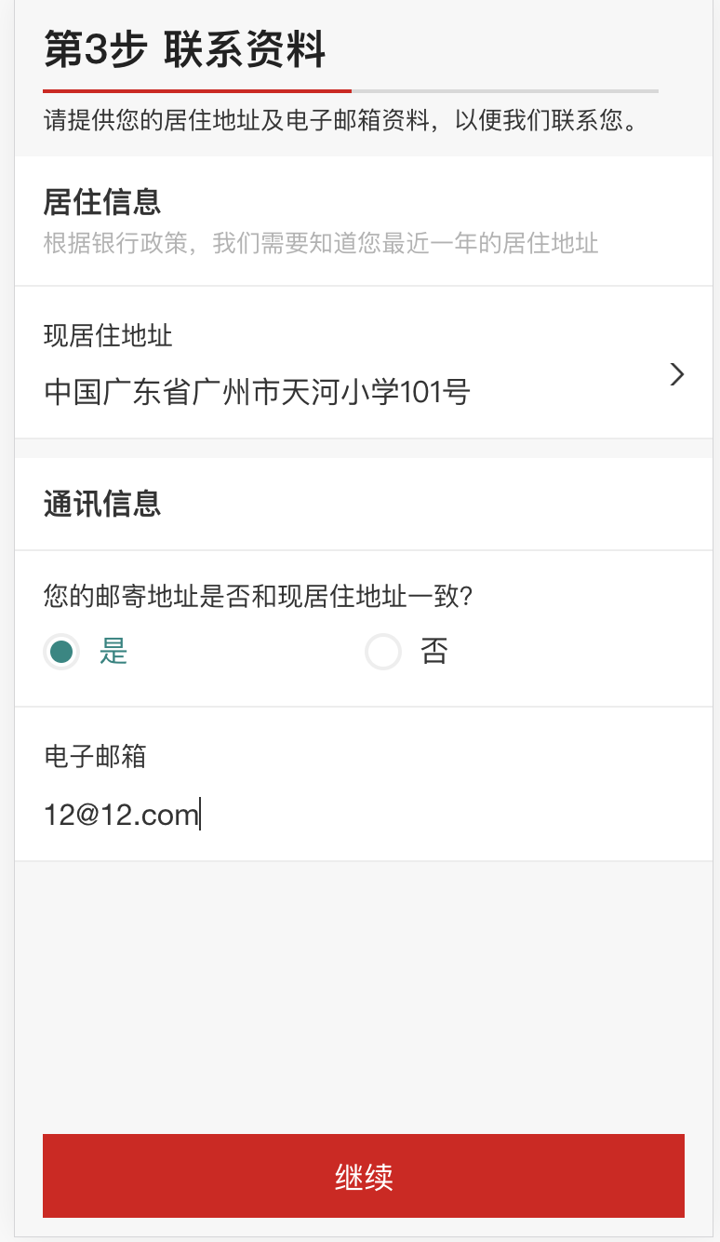

### Request Data

/api/smo/secure/applications/5eeaa18dd5efccc8d9f1f7ec/submit/contact

{"applicationId":"5eeaa18dd5efccc8d9f1f7ec","personalDetails":{"residentialStatus":{"hasPermanentResidencyInCountry":true},"customerNames":[{"nameType":"LOCAL","firstName":"猎","lastName":"黄","fullName":"黄猎"},{"nameType":"PRIMARY","firstName":"LIE","lastName":"HUANG","fullName":"HUANG LIE"},{"nameType":"FORMER_LOCAL","firstName":"小猎","lastName":"黄","fullName":"黄小猎"},{"nameType":"FORMER","firstName":"XIAO LIE","lastName":"HUANG","fullName":"HUANG XIAO LIE"},{"nameType":"ALIAS_LOCAL","firstName":"小明","lastName":"轩辕","fullName":"轩辕小明"},{"nameType":"ALIAS","firstName":"XIAO MING","lastName":"XUAN YUAN","fullName":"XUAN YUAN XIAO MING"}],"gender":"MALE","dateOfBirth":"1992-04-13","nationalityDetails":{"hasMultipleNationalities":false,"nationality":"CN","nationality2":null,"nationality3":null},"identificationDocument":{"documentType":"IDENTITY_CARD","documentReference":"440882199204130335","placeOfIssue":"雷州市公安局","startDate":"2011-12-10","expiryDate":"2021-12-10"},"countryOfBirth":"CN","countryOfResidence":null,"maritalStatus":null},"contactDetails":{"telephoneNumbers":[{"number":"13570578663","countryCode":"86","telephoneNumberType":"MOBILE"}],"emailAddressList":[{"emailType":"PERSONAL","emailAddress":"12@12.com"}],"addresses":[{"addressType":"HOME_ADDRESS","addressLine1":"中国","addressLine2":"广东省","addressLine3":"广州市","addressLine4":null,"addressLine5":"天河小学101号","postalCode":"510000","atThisAddressSince":"2018-01-01","addressCountry":"CN"},{"addressType":"IDENTITY_CARD_ADDRESS","addressLine1":"中国","addressLine2":"广东省","addressLine3":null,"addressLine4":null,"addressLine5":"下河里169号","postalCode":null,"atThisAddressSince":null,"addressCountry":"CN"},{"addressType":"CORRESPONDENCE_ADDRESS","addressLine1":"中国","addressLine2":"广东省","addressLine3":"广州市","addressLine4":null,"addressLine5":"天河小学101号","postalCode":"510000","atThisAddressSince":"2018-01-01","addressCountry":"CN"}]},"employmentDetails":{"occupation":null,"employmentStatus":null,"jobTitle":null,"industry":null,"employerName":null,"employerAddress":null},"financialDetails":{"incomePeriod":"P1Y","grossIncome":null,"otherIncome":null,"socialWelfareEligible":null,"taxResidencyInfo":{"taxResidentType":null,"taxResidentCountryOfBirth":"CN","taxResidentProvinceOfBirth":null,"taxResidentCityOfBirth":null,"taxResidencyDetails":[]}},"accountUsage":{"hasConnectedParties":null,"connectedPartiesDetails":{"hasRegularDeposit":null,"frequencyOfDeposit":"P1M","approximateDepositAmount":null},"accountPurpose":[],"reasonForAccountOpening":null,"firstDepositDetails":{"initialFundsTransferProcess":null,"initialFundsSource":null,"initialFundsSourceRemark":null,"fundsOriginationCountry":[],"initialDepositAmount":null},"cashWithdrawlAndDepositDetails":{"makesLargeCashDeposits":false,"frequencyOfLargeCashDeposits":"P1M","numberOfLargeCashDeposits":0,"approximateLargeCashDepositsAmount":null,"makesLargeCashWithdraws":false,"frequencyOfLargeCashWithdraws":"P1M","numberOfLargeCashWithdraws":null,"approximateLargeCashWithdrawsAmount":null},"internationalPaymentsDetails":{"intendToSendOrReceiveInternationalPayments":false,"regularInternationalPaymentDetails":null}},"applicationOpeningAppointment":{"branchMnemonics":null,"branchCode":"","branchLocation":null,"branchAddress":null},"customerLanguage":"zh_CN","checksDetails":[{"checkType":"AGE_CHECK","status":"NO_HIT","profileId":"AGE_CHECK_NO_HIT","codeList":[]},{"checkType":"MOBILE_CALLING_CODE_CHECK","status":"NO_HIT","profileId":"MOBILE_CALLING_CODE_CHECK_NO_HIT","codeList":[]},{"checkType":"RESIDENTIAL_ADDRESS_CHECK","status":"NO_HIT","profileId":"RESIDENTIAL_ADDRESS_CHECK_NO_HIT","codeList":[]},{"checkType":"CORRESPONDENCE_ADDRESS_CHECK","status":"NO_HIT","profileId":"CORRESPONDENCE_ADDRESS_CHECK_NO_HIT","codeList":[]}],"customerDetails":{"cdoCode":"12345678"},"referrals":[],"date":1592435217003}

### DB Data

## Emp

### UI



### Request Data

api/smo/secure/applications/5eeaa18dd5efccc8d9f1f7ec/submit/employment

{"applicationId":"5eeaa18dd5efccc8d9f1f7ec","personalDetails":{"residentialStatus":{"hasPermanentResidencyInCountry":true},"customerNames":[{"nameType":"LOCAL","firstName":"猎","lastName":"黄","fullName":"黄猎"},{"nameType":"PRIMARY","firstName":"LIE","lastName":"HUANG","fullName":"HUANG LIE"},{"nameType":"FORMER_LOCAL","firstName":"小猎","lastName":"黄","fullName":"黄小猎"},{"nameType":"FORMER","firstName":"XIAO LIE","lastName":"HUANG","fullName":"HUANG XIAO LIE"},{"nameType":"ALIAS_LOCAL","firstName":"小明","lastName":"轩辕","fullName":"轩辕小明"},{"nameType":"ALIAS","firstName":"XIAO MING","lastName":"XUAN YUAN","fullName":"XUAN YUAN XIAO MING"}],"gender":"MALE","dateOfBirth":"1992-04-13","nationalityDetails":{"hasMultipleNationalities":false,"nationality":"CN","nationality2":null,"nationality3":null},"identificationDocument":{"documentType":"IDENTITY_CARD","documentReference":"440882199204130335","placeOfIssue":"雷州市公安局","startDate":"2011-12-10","expiryDate":"2021-12-10"},"countryOfBirth":"CN","countryOfResidence":null,"maritalStatus":null},"contactDetails":{"telephoneNumbers":[{"number":"13570578663","countryCode":"86","telephoneNumberType":"MOBILE"}],"emailAddressList":[{"emailType":"PERSONAL","emailAddress":"12@12.com"}],"addresses":[{"addressType":"HOME_ADDRESS","addressLine1":"中国","addressLine2":"广东省","addressLine3":"广州市","addressLine4":null,"addressLine5":"天河小学101号","postalCode":"510000","atThisAddressSince":"2018-01-01","addressCountry":"CN"},{"addressType":"IDENTITY_CARD_ADDRESS","addressLine1":"中国","addressLine2":"广东省","addressLine3":null,"addressLine4":null,"addressLine5":"下河里169号","postalCode":null,"atThisAddressSince":null,"addressCountry":"CN"},{"addressType":"CORRESPONDENCE_ADDRESS","addressLine1":"中国","addressLine2":"广东省","addressLine3":"广州市","addressLine4":null,"addressLine5":"天河小学101号","postalCode":"510000","atThisAddressSince":"2018-01-01","addressCountry":"CN"}]},"employmentDetails":{"occupation":"PROFESSIONAL_SENIOREXECUTIVE","employmentStatus":null,"jobTitle":"BUSINESS_OWNER","industry":"INFORMATION_AND_COMUNICATION","employerName":"绿番茄","employerAddress":{"addressType":"EMPLOYER_ADDRESS","addressLine1":"中国","addressLine2":"广东省","addressLine3":"广州市","addressLine4":null,"addressLine5":null,"postalCode":null,"atThisAddressSince":null,"addressCountry":"CN"}},"financialDetails":{"incomePeriod":"P1Y","grossIncome":{"amount":"18000","currency":"CNY"},"otherIncome":{"amount":"18000","currency":"CNY"},"socialWelfareEligible":null,"taxResidencyInfo":{"taxResidentType":"IN_COUNTRY","taxResidentCountryOfBirth":"CN","taxResidentProvinceOfBirth":null,"taxResidentCityOfBirth":null,"taxResidencyDetails":[]}},"accountUsage":{"hasConnectedParties":null,"connectedPartiesDetails":{"hasRegularDeposit":null,"frequencyOfDeposit":"P1M","approximateDepositAmount":null},"accountPurpose":[],"reasonForAccountOpening":null,"firstDepositDetails":{"initialFundsTransferProcess":null,"initialFundsSource":null,"initialFundsSourceRemark":null,"fundsOriginationCountry":[],"initialDepositAmount":null},"cashWithdrawlAndDepositDetails":{"makesLargeCashDeposits":false,"frequencyOfLargeCashDeposits":"P1M","numberOfLargeCashDeposits":0,"approximateLargeCashDepositsAmount":null,"makesLargeCashWithdraws":false,"frequencyOfLargeCashWithdraws":"P1M","numberOfLargeCashWithdraws":null,"approximateLargeCashWithdrawsAmount":null},"internationalPaymentsDetails":{"intendToSendOrReceiveInternationalPayments":false,"regularInternationalPaymentDetails":null}},"applicationOpeningAppointment":{"branchMnemonics":null,"branchCode":"","branchLocation":null,"branchAddress":null},"customerLanguage":"zh_CN","checksDetails":[{"checkType":"AGE_CHECK","status":"NO_HIT","profileId":"AGE_CHECK_NO_HIT","codeList":[]},{"checkType":"MOBILE_CALLING_CODE_CHECK","status":"NO_HIT","profileId":"MOBILE_CALLING_CODE_CHECK_NO_HIT","codeList":[]},{"checkType":"RESIDENTIAL_ADDRESS_CHECK","status":"NO_HIT","profileId":"RESIDENTIAL_ADDRESS_CHECK_NO_HIT","codeList":[]},{"checkType":"CORRESPONDENCE_ADDRESS_CHECK","status":"NO_HIT","profileId":"CORRESPONDENCE_ADDRESS_CHECK_NO_HIT","codeList":[]},{"checkType":"SANCTION_LOCATION","status":"NO_HIT","profileId":"SANCTION_LOCATION_NO_HIT","codeList":[]},{"checkType":"SCC_INDUSTRY_CHECK","status":"NO_HIT","profileId":"SCC_INDUSTRY_CHECK_NO_HIT","codeList":[]}],"customerDetails":{"cdoCode":"12345678"},"referrals":[],"date":1592435280513}

### DB Data

Account



/api/smo/secure/applications/5eeaa18dd5efccc8d9f1f7ec/submit/account-usage

{"applicationId":"5eeaa18dd5efccc8d9f1f7ec","personalDetails":{"residentialStatus":{"hasPermanentResidencyInCountry":true},"customerNames":[{"nameType":"LOCAL","firstName":"猎","lastName":"黄","fullName":"黄猎"},{"nameType":"PRIMARY","firstName":"LIE","lastName":"HUANG","fullName":"HUANG LIE"},{"nameType":"FORMER_LOCAL","firstName":"小猎","lastName":"黄","fullName":"黄小猎"},{"nameType":"FORMER","firstName":"XIAO LIE","lastName":"HUANG","fullName":"HUANG XIAO LIE"},{"nameType":"ALIAS_LOCAL","firstName":"小明","lastName":"轩辕","fullName":"轩辕小明"},{"nameType":"ALIAS","firstName":"XIAO MING","lastName":"XUAN YUAN","fullName":"XUAN YUAN XIAO MING"}],"gender":"MALE","dateOfBirth":"1992-04-13","nationalityDetails":{"hasMultipleNationalities":false,"nationality":"CN","nationality2":null,"nationality3":null},"identificationDocument":{"documentType":"IDENTITY_CARD","documentReference":"440882199204130335","placeOfIssue":"雷州市公安局","startDate":"2011-12-10","expiryDate":"2021-12-10"},"countryOfBirth":"CN","countryOfResidence":null,"maritalStatus":null},"contactDetails":{"telephoneNumbers":[{"number":"13570578663","countryCode":"86","telephoneNumberType":"MOBILE"}],"emailAddressList":[{"emailType":"PERSONAL","emailAddress":"12@12.com"}],"addresses":[{"addressType":"HOME_ADDRESS","addressLine1":"中国","addressLine2":"广东省","addressLine3":"广州市","addressLine4":null,"addressLine5":"天河小学101号","postalCode":"510000","atThisAddressSince":"2018-01-01","addressCountry":"CN"},{"addressType":"IDENTITY_CARD_ADDRESS","addressLine1":"中国","addressLine2":"广东省","addressLine3":null,"addressLine4":null,"addressLine5":"下河里169号","postalCode":null,"atThisAddressSince":null,"addressCountry":"CN"},{"addressType":"CORRESPONDENCE_ADDRESS","addressLine1":"中国","addressLine2":"广东省","addressLine3":"广州市","addressLine4":null,"addressLine5":"天河小学101号","postalCode":"510000","atThisAddressSince":"2018-01-01","addressCountry":"CN"}]},"employmentDetails":{"occupation":"PROFESSIONAL_SENIOREXECUTIVE","employmentStatus":null,"jobTitle":"BUSINESS_OWNER","industry":"INFORMATION_AND_COMUNICATION","employerName":"绿番茄","employerAddress":{"addressType":"EMPLOYER_ADDRESS","addressLine1":"中国","addressLine2":"广东省","addressLine3":"广州市","addressLine4":null,"addressLine5":null,"postalCode":null,"atThisAddressSince":null,"addressCountry":"CN"}},"financialDetails":{"incomePeriod":"P1Y","grossIncome":{"amount":"18000","currency":"CNY"},"otherIncome":{"amount":"18000","currency":"CNY"},"socialWelfareEligible":null,"taxResidencyInfo":{"taxResidentType":"IN_COUNTRY","taxResidentCountryOfBirth":"CN","taxResidentProvinceOfBirth":null,"taxResidentCityOfBirth":null,"taxResidencyDetails":[]}},"accountUsage":{"hasConnectedParties":null,"connectedPartiesDetails":{"hasRegularDeposit":false,"frequencyOfDeposit":"P1M","approximateDepositAmount":null},"accountPurpose":["SALARY","OTHERS"],"reasonForAccountOpening":"大陆选择其它开户的原因","firstDepositDetails":{"initialFundsTransferProcess":"CASH","initialFundsSource":"SALARY","initialFundsSourceRemark":null,"fundsOriginationCountry":[],"initialDepositAmount":{"amount":"10000.00","currency":"CNY"}},"cashWithdrawlAndDepositDetails":{"makesLargeCashDeposits":false,"frequencyOfLargeCashDeposits":"P1M","numberOfLargeCashDeposits":0,"approximateLargeCashDepositsAmount":null,"makesLargeCashWithdraws":false,"frequencyOfLargeCashWithdraws":"P1M","numberOfLargeCashWithdraws":null,"approximateLargeCashWithdrawsAmount":null},"internationalPaymentsDetails":{"intendToSendOrReceiveInternationalPayments":false,"regularInternationalPaymentDetails":null}},"applicationOpeningAppointment":{"branchMnemonics":null,"branchCode":"","branchLocation":null,"branchAddress":null},"customerLanguage":"zh_CN","checksDetails":[{"checkType":"AGE_CHECK","status":"NO_HIT","profileId":"AGE_CHECK_NO_HIT","codeList":[]},{"checkType":"MOBILE_CALLING_CODE_CHECK","status":"NO_HIT","profileId":"MOBILE_CALLING_CODE_CHECK_NO_HIT","codeList":[]},{"checkType":"RESIDENTIAL_ADDRESS_CHECK","status":"NO_HIT","profileId":"RESIDENTIAL_ADDRESS_CHECK_NO_HIT","codeList":[]},{"checkType":"CORRESPONDENCE_ADDRESS_CHECK","status":"NO_HIT","profileId":"CORRESPONDENCE_ADDRESS_CHECK_NO_HIT","codeList":[]},{"checkType":"SANCTION_LOCATION","status":"NO_HIT","profileId":"SANCTION_LOCATION_NO_HIT","codeList":[]},{"checkType":"SCC_INDUSTRY_CHECK","status":"NO_HIT","profileId":"SCC_INDUSTRY_CHECK_NO_HIT","codeList":[]}],"customerDetails":{"cdoCode":"12345678"},"referrals":[],"date":1592435355145}

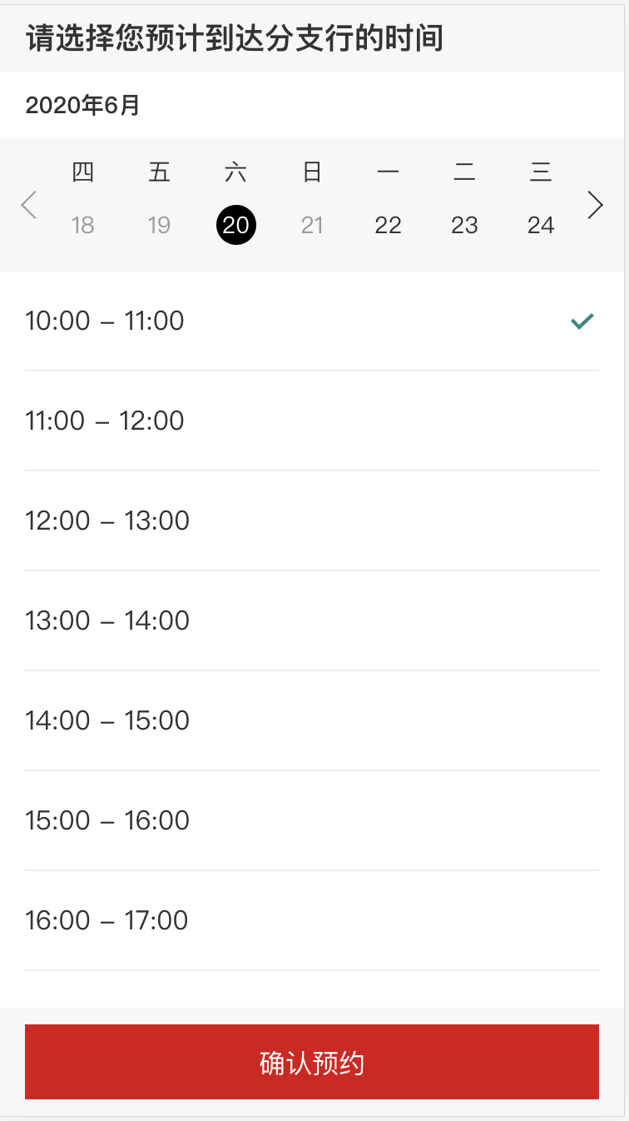

/api/smo/secure/applications/5eeaa18dd5efccc8d9f1f7ec/submit/appointment-booking

{"applicationId":"5eeaa18dd5efccc8d9f1f7ec","appointmentBooking":{"branchAppointmentTime":{"appointmentFrom":"2020-06-20T02:00:00.000Z","appointmentTo":"2020-06-20T03:00:00.000Z"}},"date":1592435395652}



api/smo/secure/applications/5eeaa18dd5efccc8d9f1f7ec/submit/appointment

{"applicationId":"5eeaa18dd5efccc8d9f1f7ec","personalDetails":{"residentialStatus":{"hasPermanentResidencyInCountry":true},"customerNames":[{"nameType":"LOCAL","firstName":"猎","lastName":"黄","fullName":"黄猎"},{"nameType":"PRIMARY","firstName":"LIE","lastName":"HUANG","fullName":"HUANG LIE"},{"nameType":"FORMER_LOCAL","firstName":"小猎","lastName":"黄","fullName":"黄小猎"},{"nameType":"FORMER","firstName":"XIAO LIE","lastName":"HUANG","fullName":"HUANG XIAO LIE"},{"nameType":"ALIAS_LOCAL","firstName":"小明","lastName":"轩辕","fullName":"轩辕小明"},{"nameType":"ALIAS","firstName":"XIAO MING","lastName":"XUAN YUAN","fullName":"XUAN YUAN XIAO MING"}],"gender":"MALE","dateOfBirth":"1992-04-13","nationalityDetails":{"hasMultipleNationalities":false,"nationality":"CN","nationality2":null,"nationality3":null},"identificationDocument":{"documentType":"IDENTITY_CARD","documentReference":"440882199204130335","placeOfIssue":"雷州市公安局","startDate":"2011-12-10","expiryDate":"2021-12-10"},"countryOfBirth":"CN","countryOfResidence":null,"maritalStatus":null},"contactDetails":{"telephoneNumbers":[{"number":"13570578663","countryCode":"86","telephoneNumberType":"MOBILE"}],"emailAddressList":[{"emailType":"PERSONAL","emailAddress":"12@12.com"}],"addresses":[{"addressType":"HOME_ADDRESS","addressLine1":"中国","addressLine2":"广东省","addressLine3":"广州市","addressLine4":null,"addressLine5":"天河小学101号","postalCode":"510000","atThisAddressSince":"2018-01-01","addressCountry":"CN"},{"addressType":"IDENTITY_CARD_ADDRESS","addressLine1":"中国","addressLine2":"广东省","addressLine3":null,"addressLine4":null,"addressLine5":"下河里169号","postalCode":null,"atThisAddressSince":null,"addressCountry":"CN"},{"addressType":"CORRESPONDENCE_ADDRESS","addressLine1":"中国","addressLine2":"广东省","addressLine3":"广州市","addressLine4":null,"addressLine5":"天河小学101号","postalCode":"510000","atThisAddressSince":"2018-01-01","addressCountry":"CN"}]},"employmentDetails":{"occupation":"PROFESSIONAL_SENIOREXECUTIVE","employmentStatus":null,"jobTitle":"BUSINESS_OWNER","industry":"INFORMATION_AND_COMUNICATION","employerName":"绿番茄","employerAddress":{"addressType":"EMPLOYER_ADDRESS","addressLine1":"中国","addressLine2":"广东省","addressLine3":"广州市","addressLine4":null,"addressLine5":null,"postalCode":null,"atThisAddressSince":null,"addressCountry":"CN"}},"financialDetails":{"incomePeriod":"P1Y","grossIncome":{"amount":"18000","currency":"CNY"},"otherIncome":{"amount":"18000","currency":"CNY"},"socialWelfareEligible":null,"taxResidencyInfo":{"taxResidentType":"IN_COUNTRY","taxResidentCountryOfBirth":"CN","taxResidentProvinceOfBirth":null,"taxResidentCityOfBirth":null,"taxResidencyDetails":[]}},"accountUsage":{"hasConnectedParties":null,"connectedPartiesDetails":{"hasRegularDeposit":false,"frequencyOfDeposit":"P1M","approximateDepositAmount":null},"accountPurpose":["SALARY","OTHERS"],"reasonForAccountOpening":"大陆选择其它开户的原因","firstDepositDetails":{"initialFundsTransferProcess":"CASH","initialFundsSource":"SALARY","initialFundsSourceRemark":null,"fundsOriginationCountry":[],"initialDepositAmount":{"amount":"10000.00","currency":"CNY"}},"cashWithdrawlAndDepositDetails":{"makesLargeCashDeposits":false,"frequencyOfLargeCashDeposits":"P1M","numberOfLargeCashDeposits":0,"approximateLargeCashDepositsAmount":null,"makesLargeCashWithdraws":false,"frequencyOfLargeCashWithdraws":"P1M","numberOfLargeCashWithdraws":null,"approximateLargeCashWithdrawsAmount":null},"internationalPaymentsDetails":{"intendToSendOrReceiveInternationalPayments":false,"regularInternationalPaymentDetails":null}},"applicationOpeningAppointment":{"branchMnemonics":"GTT","branchCode":"509,749","branchLocation":"GuangZhou","branchAddress":"广州市天河区天河路208号粤海天河城大厦首层1号商铺和写字楼第五层01、02、03和08号单位"},"customerLanguage":"zh_CN","checksDetails":[{"checkType":"AGE_CHECK","status":"NO_HIT","profileId":"AGE_CHECK_NO_HIT","codeList":[]},{"checkType":"MOBILE_CALLING_CODE_CHECK","status":"NO_HIT","profileId":"MOBILE_CALLING_CODE_CHECK_NO_HIT","codeList":[]},{"checkType":"RESIDENTIAL_ADDRESS_CHECK","status":"NO_HIT","profileId":"RESIDENTIAL_ADDRESS_CHECK_NO_HIT","codeList":[]},{"checkType":"CORRESPONDENCE_ADDRESS_CHECK","status":"NO_HIT","profileId":"CORRESPONDENCE_ADDRESS_CHECK_NO_HIT","codeList":[]},{"checkType":"SANCTION_LOCATION","status":"NO_HIT","profileId":"SANCTION_LOCATION_NO_HIT","codeList":[]},{"checkType":"SCC_INDUSTRY_CHECK","status":"NO_HIT","profileId":"SCC_INDUSTRY_CHECK_NO_HIT","codeList":[]}],"customerDetails":{"cdoCode":"12345678"},"referrals":[],"consents":[{"consentCode":"CONSENT_T_AND_C","checked":true,"checkTime":null}],"date":1592435522926}

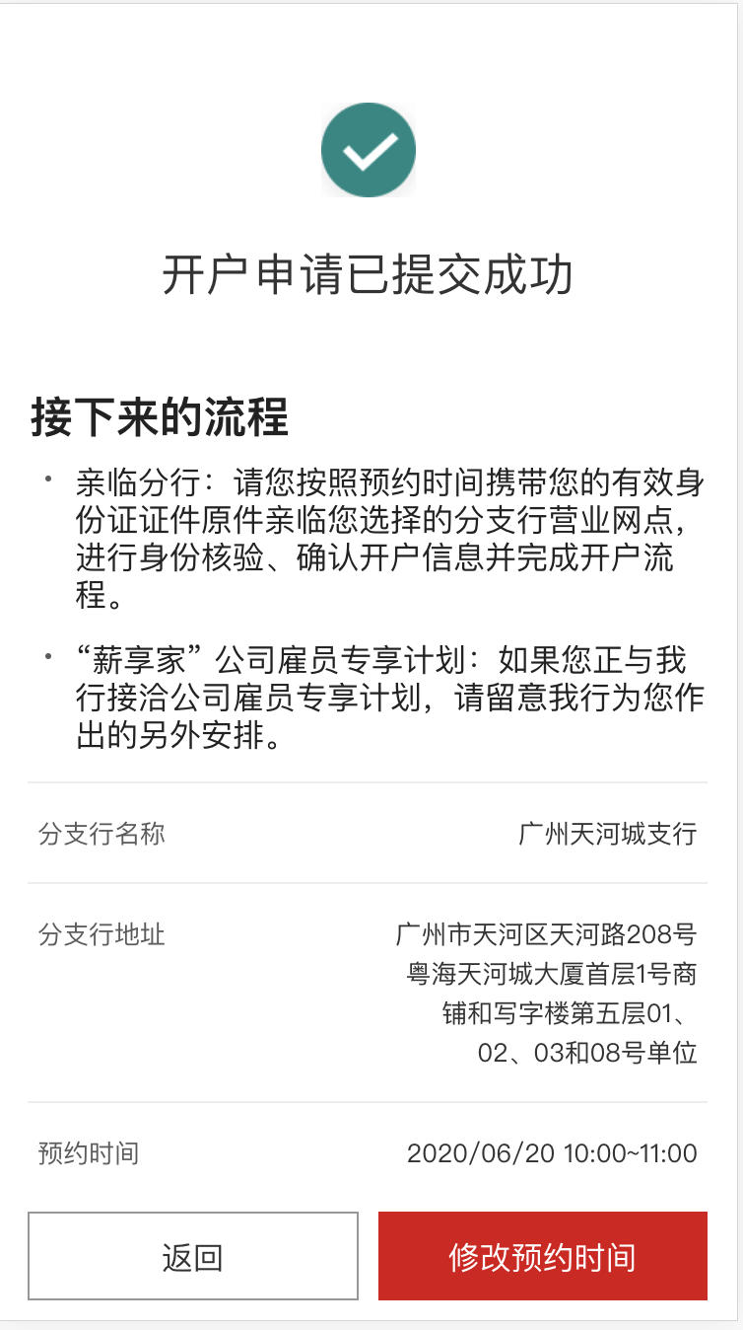

/api/smo/secure/applications/5eeaa18dd5efccc8d9f1f7ec/submit/confirm

{"applicationId":"5eeaa18dd5efccc8d9f1f7ec","personalDetails":{"residentialStatus":{"hasPermanentResidencyInCountry":true},"customerNames":[{"nameType":"LOCAL","firstName":"猎","lastName":"黄","fullName":"黄猎"},{"nameType":"PRIMARY","firstName":"LIE","lastName":"HUANG","fullName":"HUANG LIE"},{"nameType":"FORMER_LOCAL","firstName":"小猎","lastName":"黄","fullName":"黄小猎"},{"nameType":"FORMER","firstName":"XIAO LIE","lastName":"HUANG","fullName":"HUANG XIAO LIE"},{"nameType":"ALIAS_LOCAL","firstName":"小明","lastName":"轩辕","fullName":"轩辕小明"},{"nameType":"ALIAS","firstName":"XIAO MING","lastName":"XUAN YUAN","fullName":"XUAN YUAN XIAO MING"}],"gender":"MALE","dateOfBirth":"1992-04-13","nationalityDetails":{"hasMultipleNationalities":false,"nationality":"CN","nationality2":null,"nationality3":null},"identificationDocument":{"documentType":"IDENTITY_CARD","documentReference":"440882199204130335","placeOfIssue":"雷州市公安局","startDate":"2011-12-10","expiryDate":"2021-12-10"},"countryOfBirth":"CN","countryOfResidence":null,"maritalStatus":null},"contactDetails":{"telephoneNumbers":[{"number":"13570578663","countryCode":"86","telephoneNumberType":"MOBILE"}],"emailAddressList":[{"emailType":"PERSONAL","emailAddress":"12@12.com"}],"addresses":[{"addressType":"HOME_ADDRESS","addressLine1":"中国","addressLine2":"广东省","addressLine3":"广州市","addressLine4":null,"addressLine5":"天河小学101号","postalCode":"510000","atThisAddressSince":"2018-01-01","addressCountry":"CN"},{"addressType":"IDENTITY_CARD_ADDRESS","addressLine1":"中国","addressLine2":"广东省","addressLine3":null,"addressLine4":null,"addressLine5":"下河里169号","postalCode":null,"atThisAddressSince":null,"addressCountry":"CN"},{"addressType":"CORRESPONDENCE_ADDRESS","addressLine1":"中国","addressLine2":"广东省","addressLine3":"广州市","addressLine4":null,"addressLine5":"天河小学101号","postalCode":"510000","atThisAddressSince":"2018-01-01","addressCountry":"CN"}]},"employmentDetails":{"occupation":"PROFESSIONAL_SENIOREXECUTIVE","employmentStatus":null,"jobTitle":"BUSINESS_OWNER","industry":"INFORMATION_AND_COMUNICATION","employerName":"绿番茄","employerAddress":{"addressType":"EMPLOYER_ADDRESS","addressLine1":"中国","addressLine2":"广东省","addressLine3":"广州市","addressLine4":null,"addressLine5":null,"postalCode":null,"atThisAddressSince":null,"addressCountry":"CN"}},"financialDetails":{"incomePeriod":"P1Y","grossIncome":{"amount":"18000","currency":"CNY"},"otherIncome":{"amount":"18000","currency":"CNY"},"socialWelfareEligible":null,"taxResidencyInfo":{"taxResidentType":"IN_COUNTRY","taxResidentCountryOfBirth":"CN","taxResidentProvinceOfBirth":null,"taxResidentCityOfBirth":null,"taxResidencyDetails":[]}},"accountUsage":{"hasConnectedParties":false,"connectedPartiesDetails":{"hasRegularDeposit":false,"frequencyOfDeposit":"P1M","approximateDepositAmount":null},"accountPurpose":["SALARY","OTHERS"],"reasonForAccountOpening":"大陆选择其它开户的原因","firstDepositDetails":{"initialFundsTransferProcess":"CASH","initialFundsSource":"SALARY","initialFundsSourceRemark":null,"fundsOriginationCountry":[],"initialDepositAmount":{"amount":"10000.00","currency":"CNY"}},"cashWithdrawlAndDepositDetails":{"makesLargeCashDeposits":false,"frequencyOfLargeCashDeposits":"P1M","numberOfLargeCashDeposits":0,"approximateLargeCashDepositsAmount":null,"makesLargeCashWithdraws":false,"frequencyOfLargeCashWithdraws":"P1M","numberOfLargeCashWithdraws":null,"approximateLargeCashWithdrawsAmount":null},"internationalPaymentsDetails":{"intendToSendOrReceiveInternationalPayments":false,"regularInternationalPaymentDetails":null}},"applicationOpeningAppointment":{"branchMnemonics":"GTT","branchCode":"509,749","branchLocation":"GuangZhou","branchAddress":"广州市天河区天河路208号粤海天河城大厦首层1号商铺和写字楼第五层01、02、03和08号单位"},"customerLanguage":"zh_CN","checksDetails":[{"checkType":"AGE_CHECK","status":"NO_HIT","profileId":"AGE_CHECK_NO_HIT","codeList":[]},{"checkType":"MOBILE_CALLING_CODE_CHECK","status":"NO_HIT","profileId":"MOBILE_CALLING_CODE_CHECK_NO_HIT","codeList":[]},{"checkType":"RESIDENTIAL_ADDRESS_CHECK","status":"NO_HIT","profileId":"RESIDENTIAL_ADDRESS_CHECK_NO_HIT","codeList":[]},{"checkType":"CORRESPONDENCE_ADDRESS_CHECK","status":"NO_HIT","profileId":"CORRESPONDENCE_ADDRESS_CHECK_NO_HIT","codeList":[]},{"checkType":"SANCTION_LOCATION","status":"NO_HIT","profileId":"SANCTION_LOCATION_NO_HIT","codeList":[]},{"checkType":"SCC_INDUSTRY_CHECK","status":"NO_HIT","profileId":"SCC_INDUSTRY_CHECK_NO_HIT","codeList":[]},{"checkType":"CONNECTED_PARTY_CHECK","status":"NO_HIT","profileId":"CONNECTED_PARTY_CHECK_NO_HIT","codeList":[]},{"checkType":"US_INDICIA_PRE_CHECK","status":"NO_HIT","profileId":"US_INDICIA_PRE_CHECK_NO_HIT","codeList":[]},{"checkType":"TAX_RESIDENCE_CHECK","status":"NO_HIT","profileId":"TAX_RESIDENCE_CHECK_NO_HIT","codeList":[]}],"customerDetails":{"cdoCode":"12345678"},"referrals":[],"date":1592435523444}